From: eCops <alert@neighbourhoodalert.co.uk>
Sent: 25 October 2023 08:21
To: colnepc@hotmail.co.uk <colnepc@hotmail.co.uk>
Subject: Annual Tweetathon for Control Room Week [#169341164]

  
  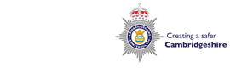

  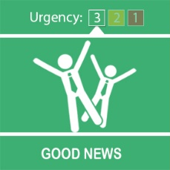
  Annual Tweetathon for Control Room Week

Dear Karen,
This week is #ControlRoomWeek, a national event which aims to show the important work of control room staff all over the country.
If you have ever wondered what a typical Friday night looks like for a Cambridgeshire Constabulary emergency call handler, you're in luck.
In order to demonstrate the reality of the demand our call handlers face, we will be taking to Twitter this Friday (27 October) between 4pm-11pm where we will be live Tweeting about every 999 call we receive.
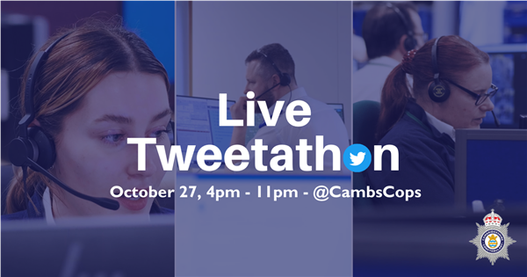
This will be our fourth annual Tweetathon after great successes in previous years. Last year saw Twitter users commenting that the event provided a “great insight into the real-life workload you handle”, while another said it “shines a light on the amount and variety of calls and issues you collectively have to deal with. Utterly engrossing seeing the tweets pop up!”
Detective Superintendent Michael Branston, head of demand, said “Friday nights are usually busy, and I fully expect our social media followers to be surprised by the volume but also really interested in the different types of demand we deal with each day."
Make sure you follow us on Twitter - @CambsCops and tune in between 4pm-11pm on Friday to learn about the volume and variety of calls we receive on a daily basis.

Kind regards,
 | Message Sent By  Lauren Watchorn  (Police, Digital Marketing Officer, Corporate Communications)

