
 | 

25 people charged following hare coursing investigation across Cambridgeshire
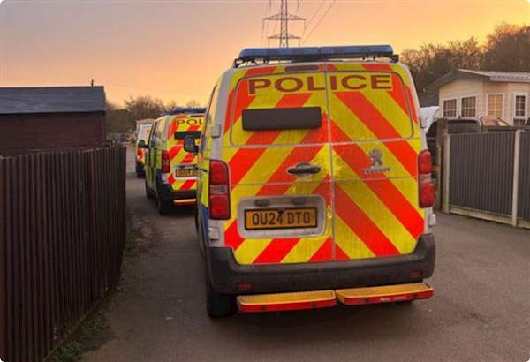

Dear Karen,
Detectives have now charged 25 individuals as part of an ongoing investigation into hare coursing and violent disorder that took place across Cambridgeshire in January.
The charges follow a series of coordinated arrests and seizures made in connection with a force-led investigation into widespread criminal activity on Saturday, 25 January.
The events, which included reports of hare coursing, criminal damage, and dangerous driving, caused significant disruption and concern in communities including Fordham, Ely, Prickwillow, Littleport, Welney, Chatteris, Manea, Wimblington and Doddington.
You can read more on our website.
Kind Regards,
Detective Inspector Matthew Selves
 |  |  |  | 

 | Message Sent By  Tara Dundon  (Police, Senior Communications Officer, All)

