
 | 

The man with the shopping bag
Dear Karen,

An elderly man walked into a care home in Huntingdon recently, but all wasn’t as it first seemed. He was let in by reception at just before 2.30pm one Friday when they thought he was a visitor.
However, care staff got talking to him and quickly realised he appeared confused, couldn’t answer any questions and only seemed to know his own name. He told staff he had been walking for a ‘long long time’ and was holding a shopping bag with a coat, a plate, some cutlery and a newspaper inside.
Thank you to the care home workers who realised something wasn’t right and called us.

Within minutes, thanks to our new Herbert Protocol form, we traced the man from the name he had given and found his next of kin’s details. We then made arrangements for the man to be taken home and reunited with the family member.
This is a great example of how our new Herbert Protocol online form is making a real difference to the most vulnerable members of our community; it’s fantastic and heartwarming for us to see.
Did you know? Our new Herbert Protocol form can be filled out online and encourages family and friends to collate key info such as a physical description, familiar places, health details and a recent photo of a loved one with dementia that will help officers if they go missing.
We’re also issuing hundreds of new yellow wristbands, like a watch in appearance, to people living with dementia in Cambridgeshire.
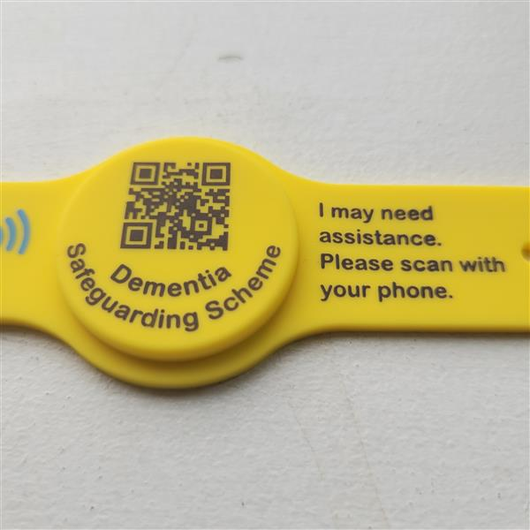
The wristbands contain the person’s next of kin’s contact details and number. If you see someone looking confused or disorientated but wearing one of these wristbands, you can use your phone to easily bring up the information and reunite the person with their family – potentially without the need to call us.
There are more than 10,000 people living in our county with dementia.
To register your interest for one of the new wristbands, or fill out our new Herbert Protocol form for a loved one, visit the dedicated page on our website.

Kind regards,
 |  |  |  | 

 | Message Sent By  Tara Cox  (Police, Communications Officer, Corporate Communications)

