
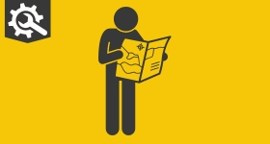 | 

Follow your local Facebook page
Dear Karen,
Want to see more of what’s happening in your local area?

From action-packed videos to community moments and more- we’ve got it all on our Facebook page!

👮‍♀️ Photos from community events
🚓 Videos from recent warrants
🎥 Bodyworn footage
🛡️ Crime prevention advice and court results
📢 Updates from all our teams

Whether you're looking for the latest news or just want to see what your local officers have been up to — we’ve got you covered.

Give us a follow, have your say and share with a friend!

Our page is open to everyone in the community and we’d love to see you there! @PolicingHuntingdonshire
Kind Regards,
Annabelle Mullee
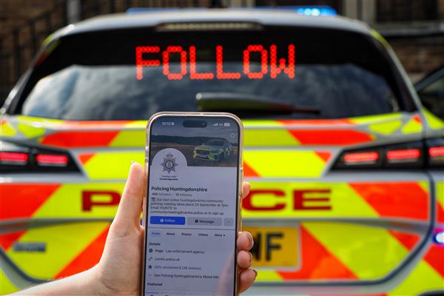

 |  |  |  | 

 | Message Sent By  Annabelle Mullee  (Cambridgeshire Constabulary, Communications Assistant, Cambridgeshire)

