
 | 

Operation Galileo Relaunched: United Front Against Hare Coursing
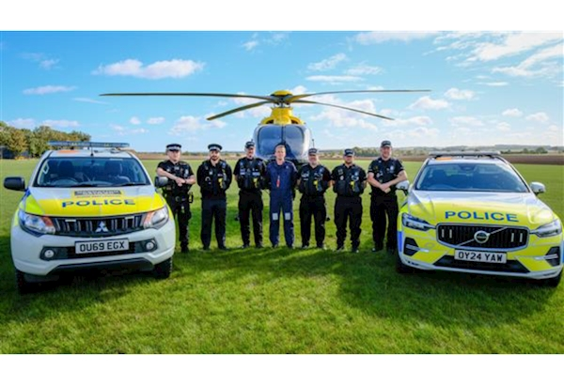

Dear Karen,
We have joined forces with Essex Police, Hertfordshire Constabulary and NPAS to re-launch Operation Galileo — a joint initiative to tackle hare coursing and rural crime.
This is more than a relaunch. It’s a clear message: we will not tolerate hare coursing or the criminality that comes with it. Borders do not protect offenders, and they do not restrict our ability to work together.
The operation includes:
• Coordinated enforcement and intelligence sharing across counties.
• NPAS aircraft supporting rural patrols and tracking offenders.
• Specialist rural crime officers responding swiftly and building strong cases for prosecution.
We’re standing shoulder to shoulder to protect our rural communities and wildlife. If you’re involved in rural policing or community engagement, please share this message and help reinforce our zero-tolerance stance.
You can read more on our website.
Kind Regards,
Sergeant Tom Nuttall
Rural Crime Action Team (RCAT)
 |  |  |  | 

 | Message Sent By  Tara Dundon  (Police, Senior Communications Officer, All)

