
 | 

Warning to #ProtectYourPension from fraud.
Savers and those reaching retirement age are being warned to protect their pensions and look out for criminals trying to catch people out of their life savings, with Action Fraud revealing a total annual loss of £17,567,249. This equates to roughly £48,129 lost to this type of fraud per day in 2024.
Data reveals there were 519 reports of pension fraud in total and £17,567,249 lost in 2024, with an average loss of £33,848 per person.
Action Fraud, with support from the Pension Scams Action Group (PSAG), launched a pension fraud awareness campaign, warning people to take extra measures to protect their pension scheme accounts and to be cautious of investment opportunity offers from criminals that could be targeting them.
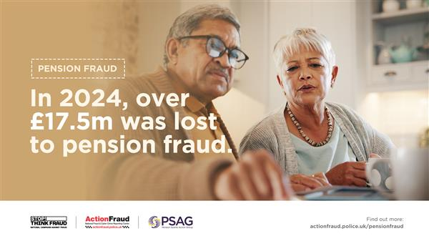
How can you protect yourself against Pension fraud?

Secure your online pension account: the account you use to manage your pension should have a different password to all of your other accounts. Use three random words to create a strong and memorable password, and enable 2-step verification (2SV).
Ignore unsolicited calls about your pension: cold calling about pensions is illegal and likely a sign of a scam. If you’re thinking about changing your pension arrangements, you should get financial guidance or advice beforehand.
Investment opportunities: don’t be rushed into making an investment. Remember, legitimate organisations will never pressure you into investing on the spot.
You should treat investment opportunities with extreme caution if there’s:
- Pressure to invest (for example: time-limited offers).
- Downplayed risk of losing your money.
- Promised returns that sound too good to be true.
Remember to Stop! Think Fraud and find more information on how to protect yourself from fraud here: Stop! Think Fraud - How to stay safe from scams
What can you do if you have been a victim of pension fraud?
Report pension scams: if you’re worried about a potential pension scam or you think you may have been contacted by a criminal, report it to Action Fraud at actionfraud.police.uk or by calling 0300 123 2040.
If you have made a payment: inform your bank or pension provider as soon as possible, they can help you prevent any further losses. Monitor your bank and pension statements regularly for any unusual activity.

Did you find the advice useful? Please give us a thumbs up below.
 |  |  |  | 

 | Message Sent By  Action Fraud

