
 | 

Men attend court charged in connection with hare coursing investigation
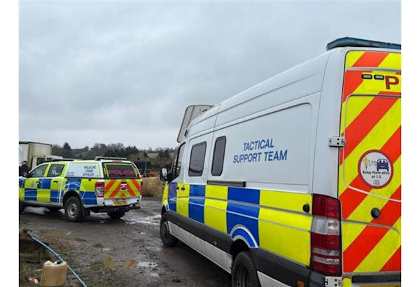

Dear Karen,
Twenty-four people have now appeared in court following a thorough investigation into incidents of hare coursing and violent disorder that took place in January.
Some have entered guilty pleas, while others have pled not guilty and will now face trial. This marks a significant step forward in the investigation and the judicial process.
We recognise the serious impact these events had on our communities and the devastation they caused. From the very outset, we made a clear commitment to carrying out a robust and comprehensive investigation.
Reaching court this month demonstrates our determination to deliver justice and to show our communities that we will not tolerate such behaviour.
More is available on our website.
Kind Regards,
Detective Inspector Matthew Selves
 |  |  |  | 

 | Message Sent By  Tara Dundon  (Police, Senior Communications Officer, All)

