
 | 

Two men banned from private and agricultural land for three years
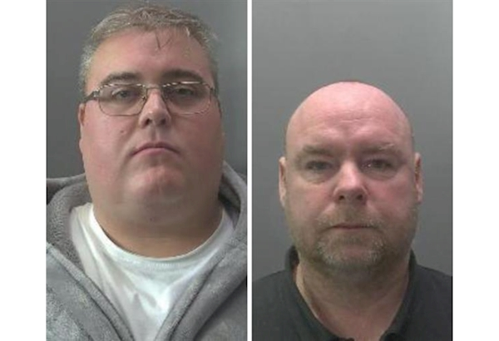

Dear Karen,
Two men have been banned from entering private and agricultural land across England and Wales following a major hare coursing investigation.
Levi Lee, 36, of Basingstoke Road, Reading, and Francie Doherty, 47, of Gipsy Lane, Wellingborough, both pleaded guilty to attending a hare coursing event on 25 January and were each fined £500.
In addition to the fines, both men were issued three-year Criminal Behaviour Orders (CBOs) at Peterborough Magistrates’ Court yesterday (1 October) which prohibit them from:
• Entering or being present on any part of private or agricultural land within England and Wales, without the written permission of the owner, which can be presented to an officer upon request.
• (For Levi Lee only) Driving any vehicle with a sighthound breed dog, whilst outside of a five mile radius of his home address, unless for a pre-arranged veterinary appointment, proof of appointment to be provided to an officer upon request.
These orders follow a force-wide investigation into hare coursing and associated criminal activity that took place on Saturday, 25 January, affecting communities across Cambridgeshire.
This is a significant milestone in our efforts to tackle hare coursing and rural crime. These CBOs are believed to be the first of their kind in the country, setting a strong precedent for how seriously this type of offending is being taken. We hope this sends a clear message to others who think they can disrupt our rural communities without consequence.
Breaching a CBO is a criminal offence that can result in up to five years in prison or an unlimited fine.
A further 20 men are due to appear in court over the coming months for sentencing and trials. See more here.
Kind Regards,
Detective Inspector Matthew Selves
Senior Investigating Officer

 |  |  |  | 

 | Message Sent By  Tara Dundon  (Police, Senior Communications Officer, All)

