
 | 

Your monthly round up
Dear Karen,
As we head further into Autumn, catch up on what our policing teams have been up to in the month of September!

Highlights from the last month:

Our Rural Crime Team attended the Gransden Show alongside Cambridgeshire Countryside Watch, engaging with visitors and handing out crime prevention advice.
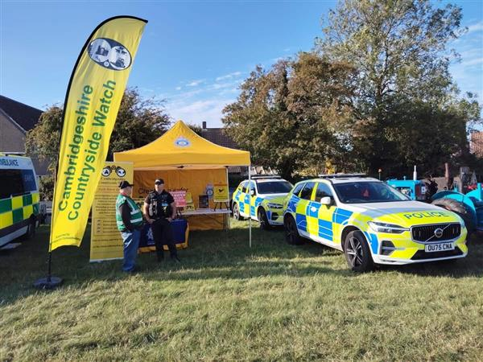
16 more bikes marked in St Ives to try and deter thieves from stealing them.
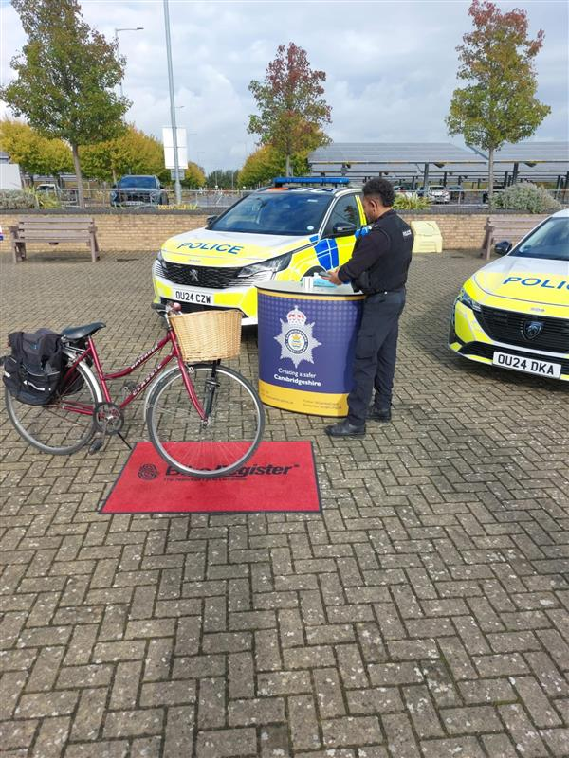
Located a stolen gator at Middle Drove after it was reported missing.
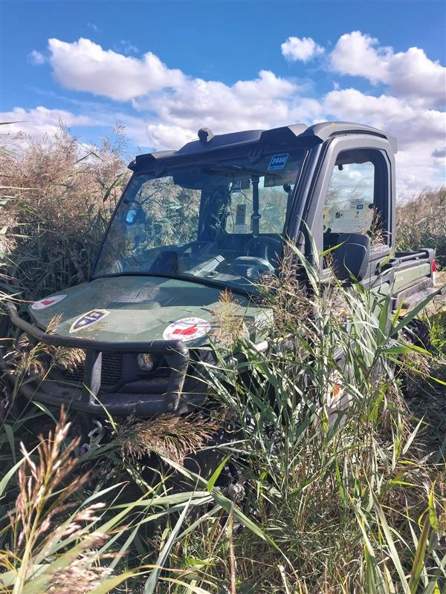
Seized more vehicles for no licence, insurance and caught a driver who provided false details by our fingerprint scanner.
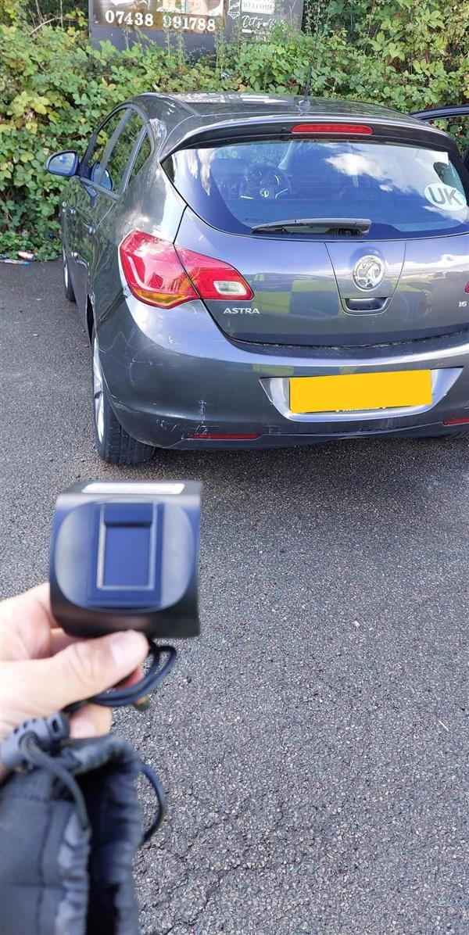
Now time for some recent court results!
Our officers work tirelessly to bring offenders before the courts and ensure justice is served.

Here’s a few from this past month:
Three men have been convicted following a violent robbery at a family-run antiques and jewellery shop in St Neots. Read more here.

Two drink drivers have been banned from the roads after being caught on the same day. More here.

A pair of drug dealers who supplied class A across Peterborough and Huntingdonshire have been ordered to pay back more than £125,000 in ill-gotten gains. More here.

More than £2,000 will be donated to charities across Cambridgeshire after a warrant at a woman’s caravan in St Neots led to the discovery of a drugs supply chain. Read more here.

Tips and tricks:
One of the main priorities of our Huntingdon Neighbourhood team is anti-social driving and motorbike and moped thefts.
We have recently been out responding to your concerns, but here are a few tips on how to keep your motorbike safe in the meantime:
1.Lock - Use a disc lock to help secure the front brake disc or a D lock on the front wheel to stop your moped being wheeled away.
2.Chain -Use a chain lock through the back wheel, this will prevent thieves from wheeling it away!
3.Cover - Make sure to cover your motorbike or moped. Thieves are often on the lookout for particular bike models; this will instantly make it less attractive to them!
Antisocial use of a vehicle, such as street racing, street cruising or off-road use is more than a matter of noise pollution, it can have a wider impact on a neighbourhood or community.
For more advice head to our website.
This is just some of what we have been up to this month, we are always working to protect the public and being visible and approachable in the communities.
If you would like to share any concerns, why not pop along to one of our community events?
We regularly host a ‘Coffee with a Cop’ and ‘Police Surgeries’ to understand the issues that are impacting you. For more updates on our next event, head to our website.
If you can’t make it to chat to us in person, report it online.
Alternatively, have your say at our next online community meeting on Monday 15th December at 7pm. If you are interested in joining us, email ‘Hunts’ to communitymeeting@cambs.police.uk and you will be sent a Teams invite.
Do you follow our local Facebook pages?
Whether you're looking for the latest news or just want to see what your local officers have been up to — we’ve got you covered.
Our page is open to everyone in the community, and we’d love to see you there!@PolicingHuntingdonshire
Kind Regards,
Annabelle Mullee
 |  |  |  | 

 | Message Sent By  Annabelle Mullee  (Cambridgeshire Constabulary, Communications Assistant, Cambridgeshire)

