
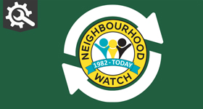 | 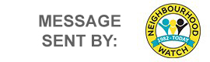

Take part in the 2025 Crime & Community Survey
Hello Karen

Our annual Crime & Community Survey is now live, and we want to hear from you. Your experiences, concerns, and insights help shape the work we do and ensure our efforts reflect the needs of the community. The survey takes around 10 minutes to complete, and every response makes a real difference. Your voice helps influence our priorities and contributes directly to the report we publish on our website.

The survey is open until 1 December 2026 — but there’s no need to wait.

👉 Share your views today: https://www.surveymonkey.com/r/9NYQ8DH

Thank you for taking the time to help make our community safer and stronger.

Kind regards

CENTRAL SUPPORT TEAM | Neighbourhood Watch Network

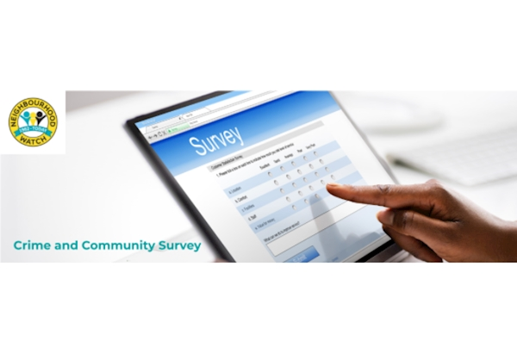
 |  |  |  | 

 | Message Sent By  Cheryl Spruce  (NWN, Head of Membership & Community Engagement, England and Wales)

