
 | 

Report Fraud launches
This week, the City of London Police, the national lead force for fraud, announced the full public launch of Report Fraud, which has now officially replaced Action Fraud.

A new media and advertising campaign is going live from Monday 19 January to help raise awareness of the brand-new service for reporting cyber crime and fraud.

The advertising campaign will run across radio and social channels, featuring the service’s clear new visual identity and message, ‘Every Report Counts’.

Please see our campaign hero film here: https://youtu.be/CpZRbpNxCOM
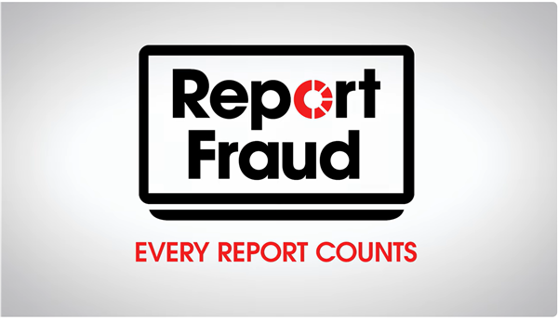

For more information, you can read more of our press release here: Report Fraud launches | City of London Police.

To report cyber crime and fraud: UK's Home for Reporting Cyber Crime & Fraud - Report Fraud.
 |  |  |  | 

 | Message Sent By  Report Fraud

